|  |
| --- |
| BOĞAZİÇİ UNIVERSITY 2021-2022 SPRING |
| CET 372 FINAL PROJECT REPORT |
| ONUR CAN CANSU |

|  |
| --- |
| Instructor: Oğuz AK  6-2-2022 |

**INTRODUCTION:**

Our player arrives in an environment he has never been to before, it is a space environment. The guide tells our player about the environments and missions he will encounter. Finally, by telling him what to do after going through all the stages, he explains his real mission and our player is ready to start the game.

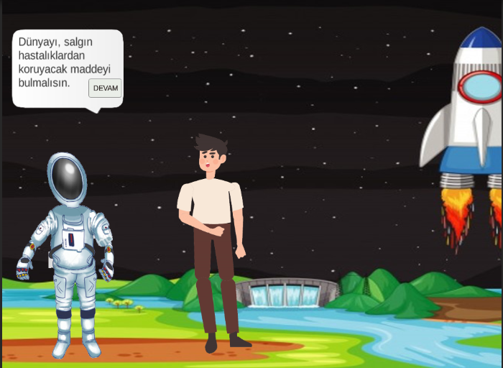

1. **ACTIVITY:**

Our player must first pass the two-stage security system. In the first stage, animations of cookies, water and steam are played with the help of buttons. Next,according to the instructıons he is asked to determine the states of matter by choosing between solid, liquid and gas. Then, by marking the properties of the items with the help of checkboxes, they are asked to determine which feature belongs to which item.

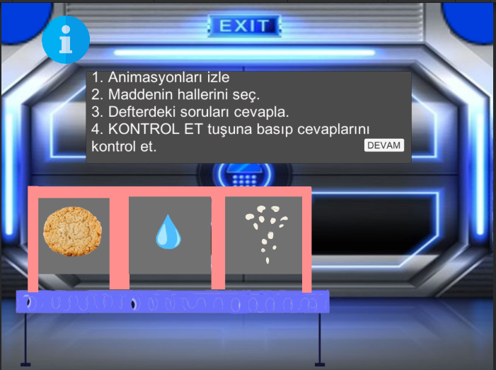

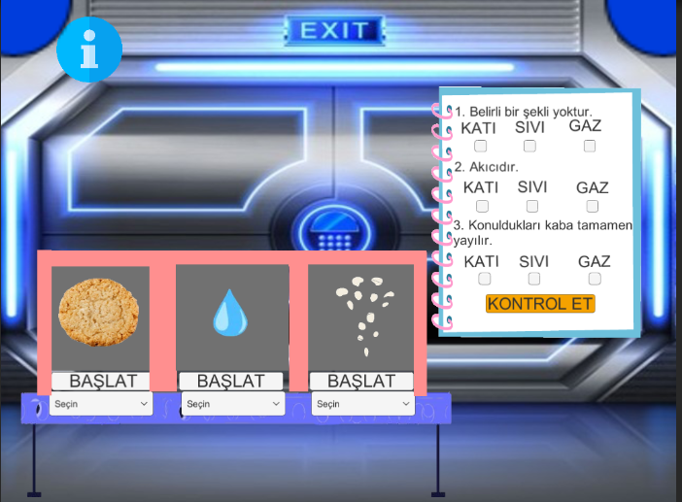

**2.ACTIVITY**

It's the final stage of this encryption system. Here, first you will get instructions. Later, he will play the animations and watch the state changes of the matter and will complete the activity by placing the melting, freezing and evaporation expressions from the TutSür machine in the appropriate places. Finally, he will check his question by pressing the “KONTROL ET” button.

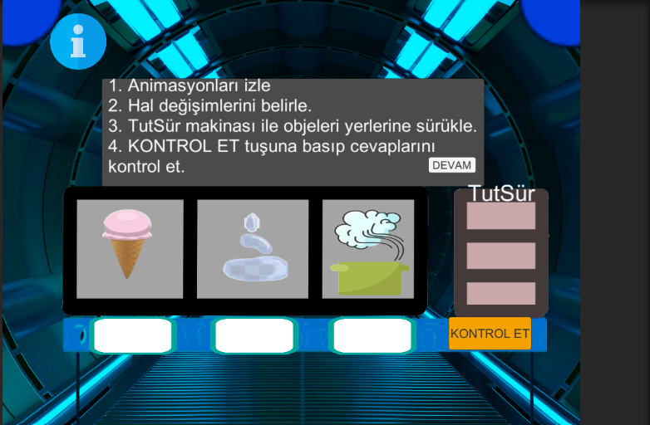

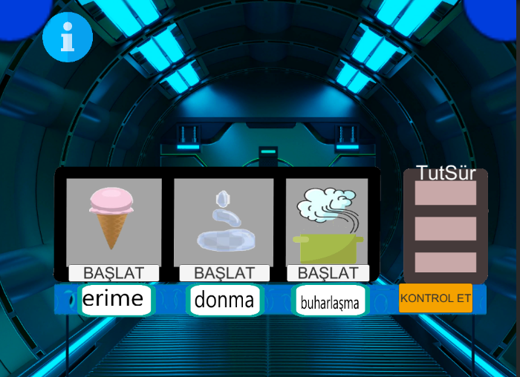

**3.ACTIVITY**

His sister has a birthday party and our player needs to cool the lemonade. He takes the ice, then first measures and records the initial state of the pitcher. Then, he puts the ice block in the corresponding place and the animation of the falling ice plays. After the ice is poured, he measures the volume of the jug and takes notes, answers the questions after seeing the difference.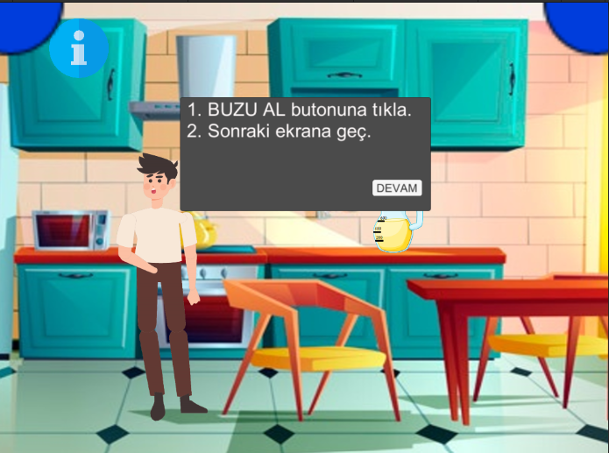

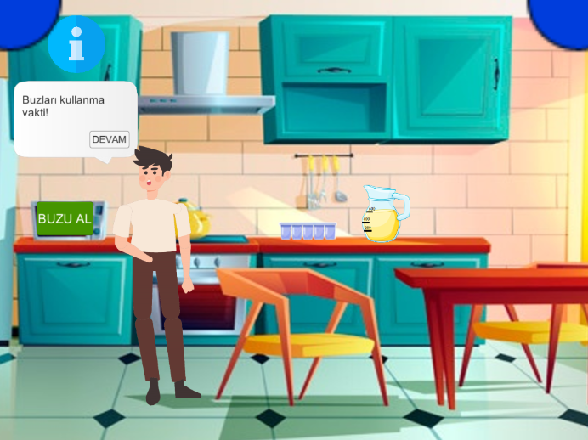

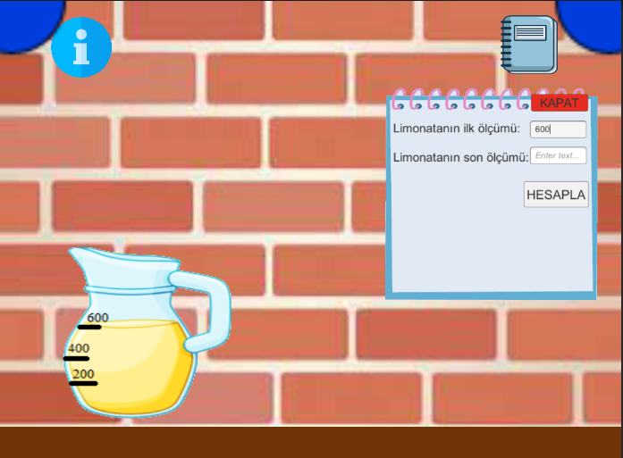

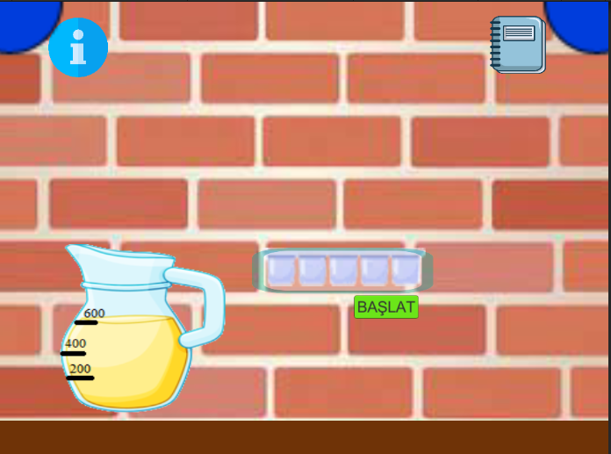

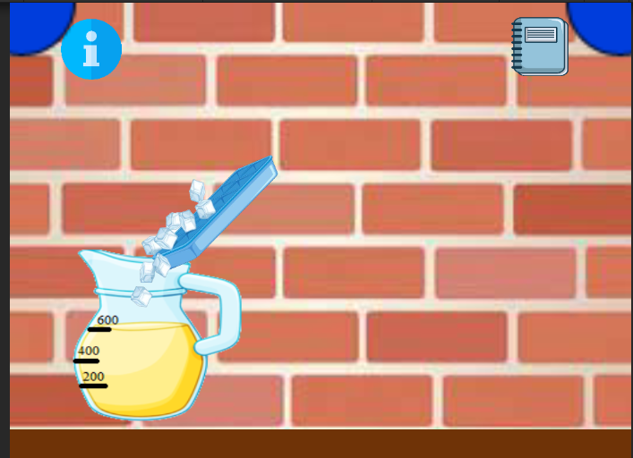

**4.ACTIVITY**

Our player needs to create ice in case it needs ice again. the ice mold fills the water from the tap while the animation about this situation plays. Then, the water-filled ice block is placed in the freezer and the water is expected to freeze and turn into ice, while our player answers questions about this activity.

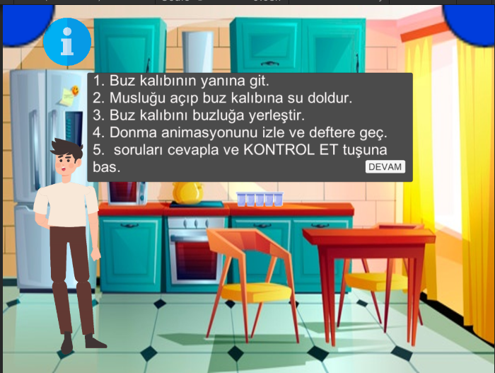

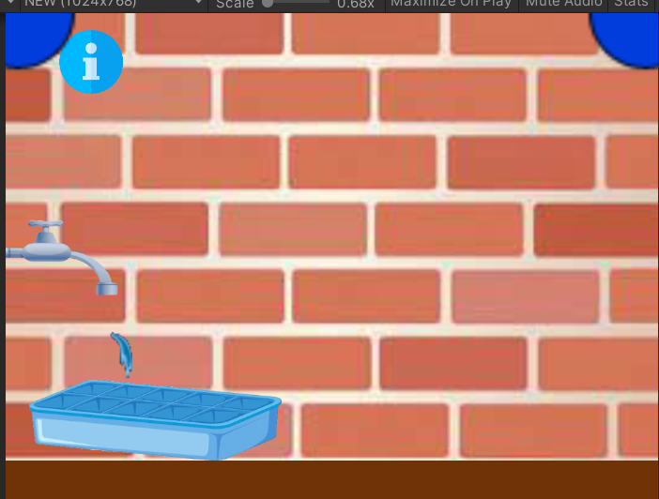

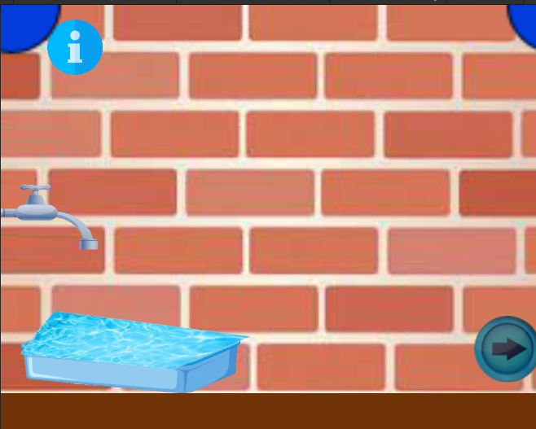

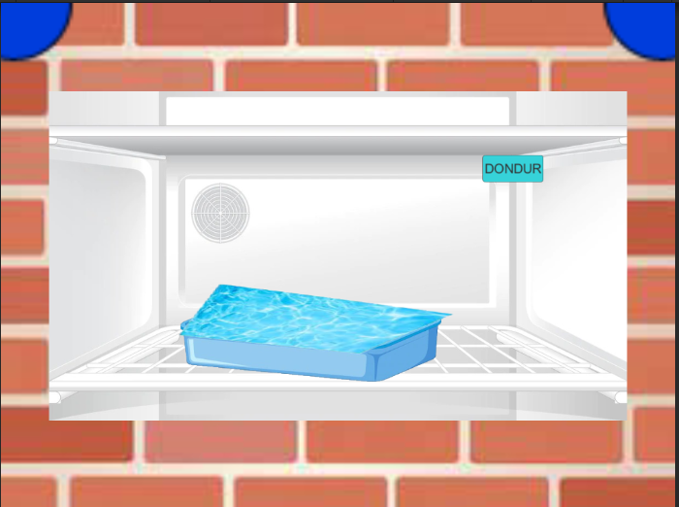

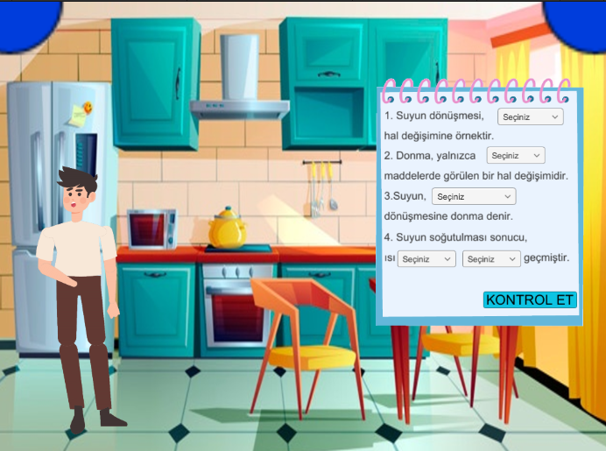

5.ACTIVITY

Her sister, who drank cold lemonade, fell ill. Our player first encounters an event to see which device to measure his temperature with, and by dragging the expressions related to these devices to the relevant places, he reaches the device he needs to use and measures his sister's temperature.

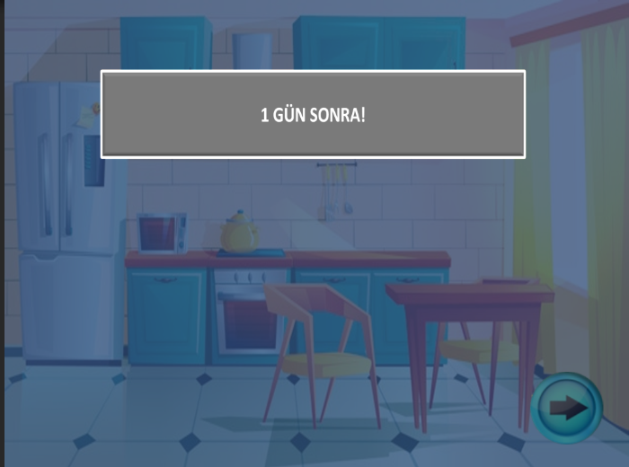

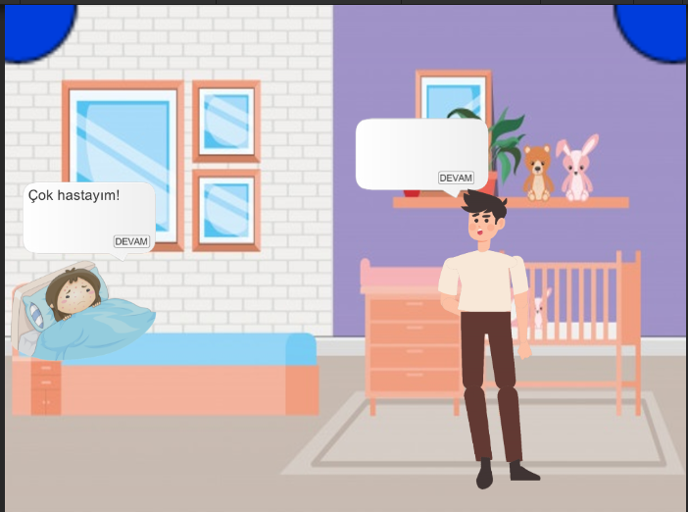

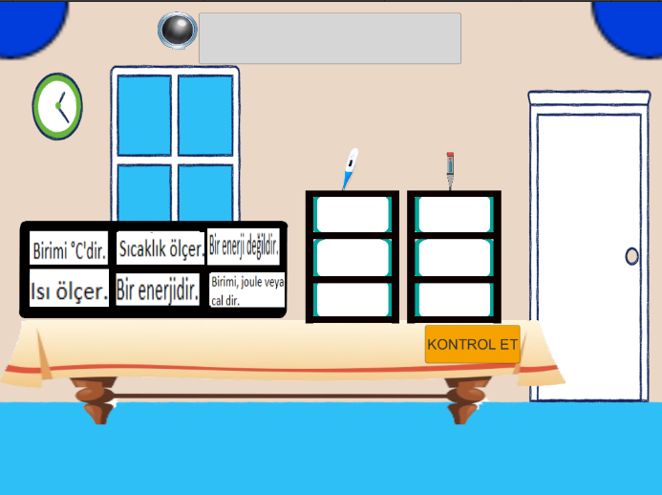

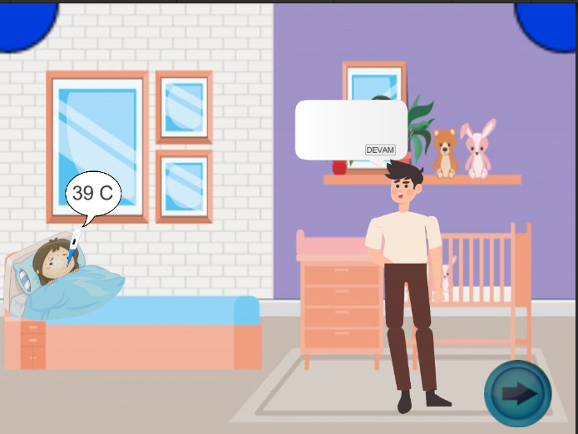

**6.ACTIVITY**

He places a wet cloth on his forehead to reduce his sister's fever, watches the animation about it, and then answers questions he comes across.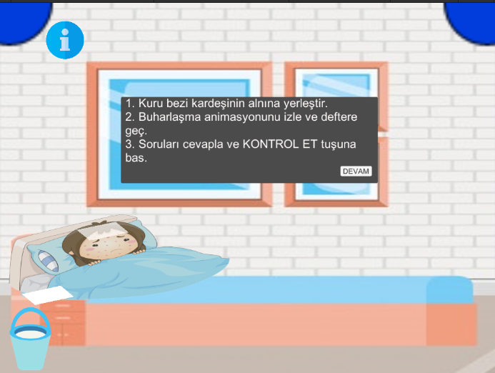the

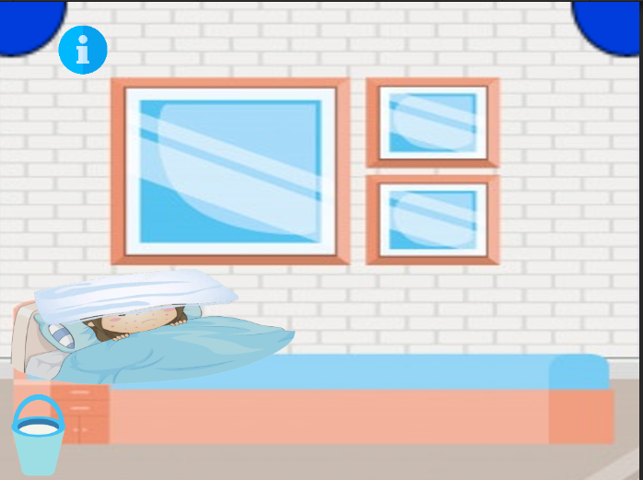

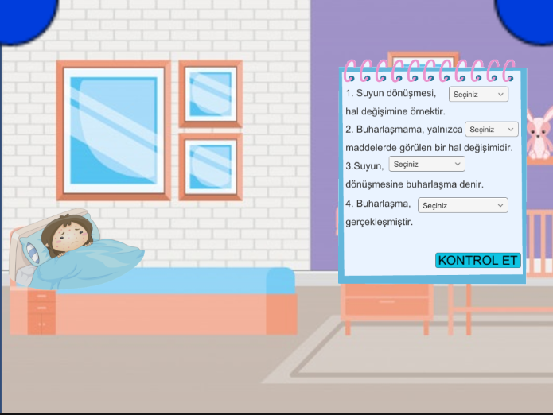

7.ACTIVITY

He will bring soup for his sister so that he can recover a little faster. Seeing bubbles form on the lid of the pot when he heats the soup pot, our player will answer questions about condensation. At the end of the activity, the sister will ask our player to cool her soup.

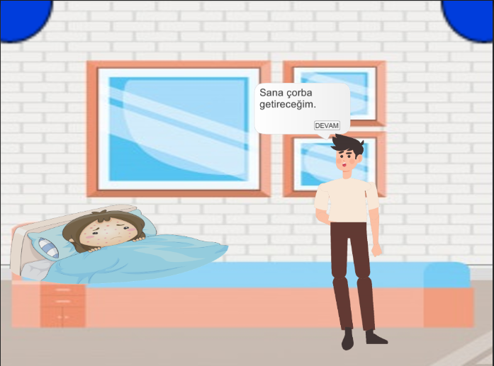

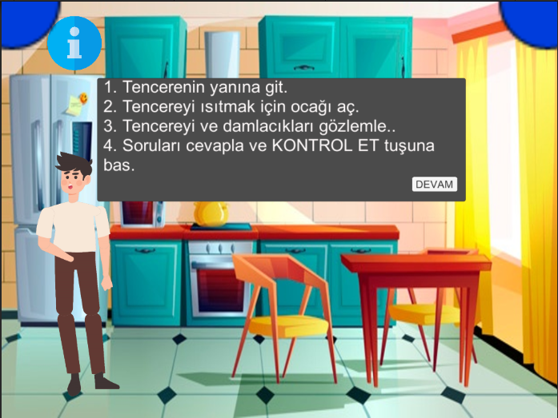

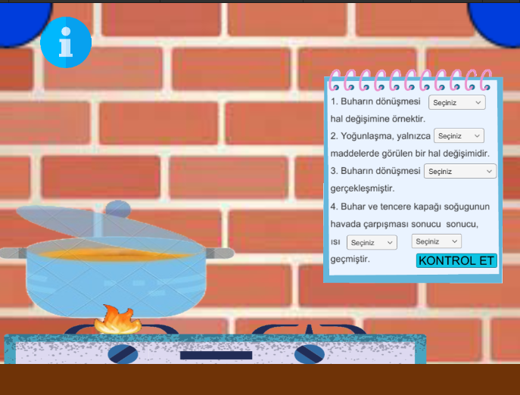

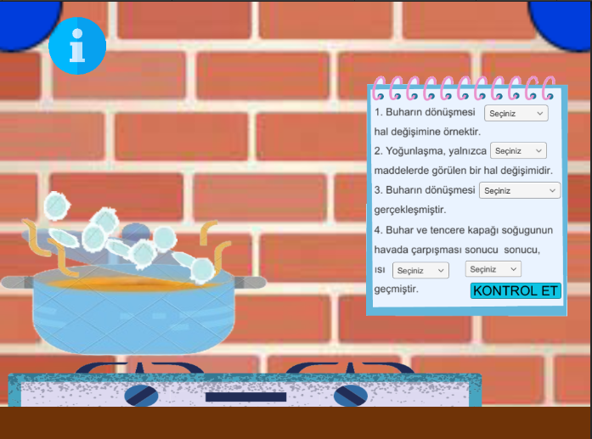

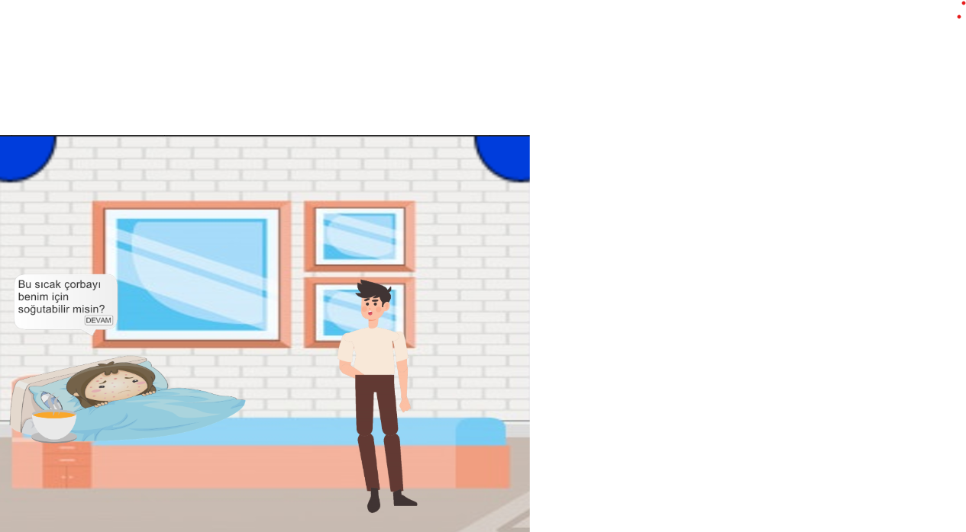

8.ACTIVITY

First, he goes to the kitchen and sees his ingredients on the counter. Later, when he looks at the notebook, he sees that the first temperatures of the items are given. Then he watches as the water is poured into the soup. Records the last temperatures in the notebook. Finds the temperature of the mixture and understands the equilibrium temperature from the questions asked. 